**Suggested Question Bank.**

**Module 1:**

**Introduction**

1. **Compare** NOS DOS, middleware (Hardware and Software Concepts)
2. What do you understand by a distributed system
3. What are the types of DS**(Justify with example)**
4. What are the various transparencies **(Justify with example)**
5. What are the applications for DS **(Justify with example)**
6. What are the services offered by a DS **(Justify with example)**
7. What are the goals of DS **(Justify with example)**
8. What are the models of DS **(Justify with example)**

**Module 2:**

**Communication and message Passing**

1. What are the ways by which IPC can take place? **( Analyse and Justify)**
2. What is the difference between message passing and shared memory models?
3. TCP/IP communication offers what kind of transparencies **(Justify)**
4. What is the Listen Accept combination of primitives defining in TCP IP communication model
5. What are persistent and transient model of messages, give example**.(Design)**
6. What is MOM? Stream Communication **(Compare)**
7. What do you understand by group communication? What are the challenges of group communication over 1:1 communication.**(Justify)**
8. What are various types of group communication models? Give example application for each **( Analyse and Justify)**

**Remote Procedure call**

1. What is RPC/RMI model explain.

2. What is the need for client and server stub, **( Analyse and Justify)**

3. How call by reference and call by value implemented **(Design)**

4. How is object passed as reference in RMI **(Justify)**

5. What is lightweight RPC. What is call back RPC **(Design)**

6. What are the call semantics of RPC

7. How is failure handled in RPC

**Module 3:**

**Synchronization**

1. Why is synchronization required is DS, **(Justify with example)**

2. What do you think of physical clock and logical clock,**(Justify with example)**

3. What are the algos for physical/ logical clock synchronization **(Design)**

4. How is concurrency and causal event ordering established.**( Analyse and Justify)**

5. What are the coordinator selection solutions in a DS **(Compare performance)**

6. How is mutual exclusion handled in a DS in a centralized/distributed way.

7. Explain christian’s/Berkly’s physical clock synchronization algorithm

8. What is mutual exclusion.Explain distributed algorithm for achieving mutual exclusion.

9. **Explain** Token based 3 /non token based 3 algorithms.**(Compare and Evaluate)**

**Module 4:**

**Resource management**

1. Why do you think resource management is important?**(Justify)**

2. What are the desirable features/issues of a global scheduling management.**(Justify)**

3. How is Task Assignment Approach different from Load balancing technique.**(compare)**

4. Approaches of Load balancing (**(Compare and Evaluate))**

5. What are load sharing approaches**(Design)**

6. Give examples of applications for each type of resource management technique. **(Justify with example)**

**Process management**

1. Understanding of Process and threads**(prerequisite )**

2. What do you understand about code migration?

3. What is Process to resource and resource to machine binding **(Justify with example)**

4. What do mobile agents do? ( Content Beyond Syllabus)

5. How process migration is different from code migration

6. How is it implemented for heterogeneous systems

7. Explain virtualization **(Justify with example)**

**(Evaluate)**

Solve for following the example of task scheduling having 6 tasks and 2 nodes and given following inter task communication cost and execution cost and execution costs. solve for serial and optimal assignment;

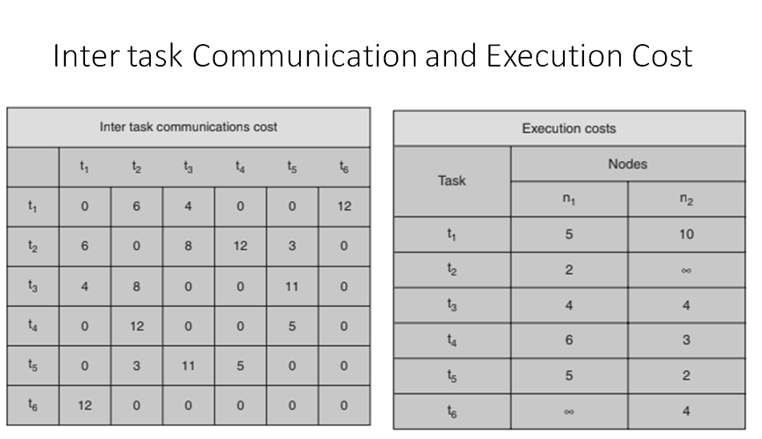

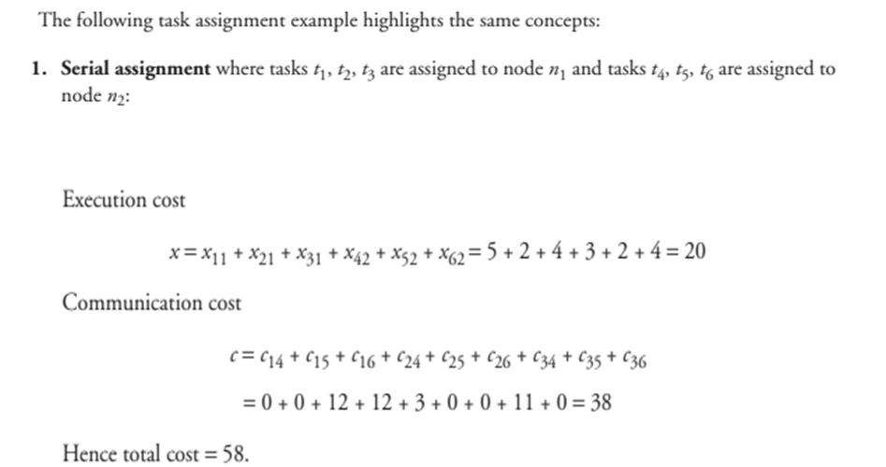

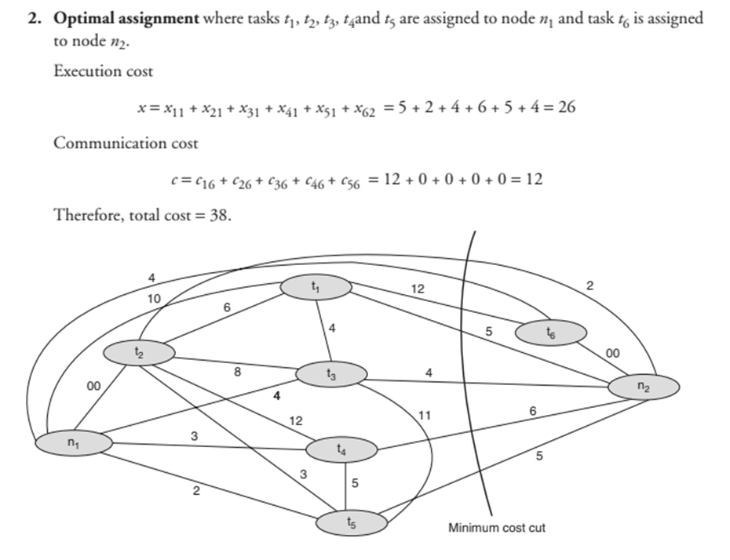

**Module 5:**

**Consistency and replication**

1) What do you understand about memory coherence and consistency?

2) What are data centric consistency models **(Compare), (Justify with example)**

3) What are client centric data consistency models? **(Compare), (Justify with example)**

4) What do you understand by eventual consistency?

5) Explain the various types of replica and list out the replication models

6) Explain weak consistency models.**(Compare)**

7) What are different replication models and how is replica location decided.**(Justify)**

8) what are the various approaches of replica consistency management

**Fault Tolerance**

1. Explain various failure models(example of DS)
2. What is the **difference** between failure detection and masking. Give advantage/disadvantage
3. Explain the need to build resilience in group of processes.
4. How is agreement achieved in a group of processes in presence of failure . Explain with help of Byzantine General problem. **(Justify )**
5. Justify Blockchain is a BFT ( Content Beyond Syllabus)
6. What are the ways by which process resilience and reliability are built in a group of processes.
7. What is global cut
8. How do achieve atomic multicasting via “View Synchrony” **(Justify with example)**
9. **How** “View Synchrony” preserves message ordering **(Justify with example)**
10. Explain how Orphans and Domino's effects are managed while recovery**.** **(Justify with example)**

**Module 6:**

**Distributed File Management**

1) What are the file-accessing models?

2) Features of good DFS and Naming schemes and Naming services.

2) What are file-sharing semantics along with file caching schemes?

3) How is file replication handled.

4) How fault tolerance is built in a DFS **(Justify and Design)**

5) What are transaction-based file systems and its operations?

6) Explain NFS and AFS**.( Design and Compare)**

7) DNS and RR**(Design)**

8) Explain GFS and, GFS cluster, Chubby and Big Table structure

9) What is directory service X.500 **(Design)**